

MENTAL HEALTH ASSISTANT
VERSION 3 (MHA3)
INSTALLATION GUIDE

PATCH YS*5.01*103

March 2012

Department of Veterans Affairs
Office of Information and Technology (OIT)
Product Development

Revision History

Date | Revision | Description | Author(s)
3/2012 | 1.0 | Initial Baseline Version | MHE Team & Susan Stephens (PSI)

Table of Contents

Preface 1
Section 508 of the Rehabilitation Act 1
Test Sites 1
Software and Documentation Retrieval Information 2
MHA3 Documentation Website Locations 2
VistA Documentation Library (VDL): 2
Anonymous Software Directory 2
MHA3 Software and Documentation Files Retrieval Formats 3
Introduction 5
Security Information 5
Security Management 5
Security Features: 5
Remote Systems: 6
Archiving/Purging: 6
Contingency Planning: 6
Interfacing: 6
Electronic Signatures: 6
Menus 7
Security Keys: 7
File Security: 7
References: 7
Official Policies: 7
Pre-Installation Information 8
Edit TIU Document Definitions: 8
Recommended Users: 9
Information Resources Management (IRM) Staff 9
Clinicians 9
Windows Conventions 9
VistA Operating System 9
VistA Operating System Performance Capacity 9
MHA3 Software Application Installation Time 9
Users on the System 9
Kernel Installation and Distribution System (KIDS) 10
Namespace 10
MHA3 Software Application Requirements 10
Required Patch 10
MHA3 Menu/Options Changes 10
Routine Summary 10
Installation Instructions 11
Server: 11
Client: GUI Software 12
IRM Staff: 12
Mental Health Assistant Install, Windows Illustrations 13
Installing Mental Health Assistant on your Computer 13
Choose Destination Location 13
Folder Does Not Exist 15
Select Start Menu Folder 16
Select Additional Tasks 17
Installing Mental Health Assistant 3 19
Completing the Mental Health Assistant 3 Setup Wizard 20
Non-M Software Distributed with Mental Health Assistant 3 (MHA3) 20
Post Installation Instructions 22
Uninstalling MHA3 22
Installing SecureDesktop Functionality in MHA3 23
SecureDesktop & Screen Pass : How to correct Windows-Registry problems. 33
SecureDesktop : How to correct dwlGina2.dll problems. 33
Setting up VistA MHA3 on CPRS GUI Tools Menu 35
Setting up VistA MHA3 on CPRS GUI Tools Menu for SecureDesktop 37
Setting up VistA so that individual MHA3 assessments are also listed on the CPRS GUI Tools Menu 39

Preface

The Veterans Health Information Systems and Architecture (VistA) Mental Health Assistant Version 3 (MHA3) Installation Guide Patch YS*5.01*103 provides detailed instructions and requirements for installing and implementing the Graphical User Interface (GUI) software application.

Section 508 of the Rehabilitation Act

NOTE: The Veterans Health Administration (VHA) fully supports Section 508 of The Rehabilitation Act and is committed to equal access for all users. While every effort has been made to ensure Section 508 compliance, we realize that there may be other issues. If you have questions or would like to see a copy of the Compliance Action Plan for future releases, please contact:

Heather Lewis, Project Manager
Heather.Lewis@va.gov
732-440-9632
Mental Health Enhancements
Product Development
Project Management Team 5

Test Sites

VistA MHA3 Patch YS*5.01*103 has been tested by the following Veteran Affairs Medical Centers (VAMCs) and Healthcare Network Systems (HCS):

Test Sites/Integrated | Operating System Platform | Test Site Size
Atlanta, GA VAMC | Cache/VMS | Large
Upstate New York HCS | Cache/VMS | Large/Integrated
St. Louis (Heartland East HCS) | Cache/VMS | Large/Integrated
Durham, NC | Cache/VMS | Large
Hines, IL VAMC | Cache/VMS | Large

Software and Documentation Retrieval Information

MHA3 Documentation Website Locations

VistA MHA3 Installation Guide (i.e., YS501103_MHA3_IG.pdf and YS501103_MHA3_IG.doc), User Manual (i.e., YS501103_MHA3_UM.pdf and YS501103_MHA3_UM.doc) and Release Notes (YS501103_MHA3_RN.pdf and YS501103_MHA3_RN.doc) are available in MS Word Format (doc) and Portable Document Format (pdf) at the following Website location:

VistA Documentation Library (VDL):
http://www.va.gov/vdl/

Anonymous Software Directory

VistA MHA3 Installation Guide (i.e., YS501103_MHA3_IG.pdf and YS501103_MHA3_IG.doc), User Manual (i.e., YS501103_MHA3_UM.pdf and YS501103_MHA3_UM.doc) and Release Notes (YS501103_MHA3_RN.pdf and YS501103_MHA3_RN.doc), are available in MS Word Format (doc) and Portable Document Format (pdf) in the Office of Information Field Offices (OIFOs) ANONYMOUS SOFTWARE directory FTP addresses listed below:

NOTE: All sites are encouraged to use the File Transfer Protocol (FTP) capability. Use the FTP address “download.vista.med.va.gov” (without the quotes) to connect to the first available FTP server where the files are located.

OIFOs | FTP ADDRESS | DIRECTORY
ALBANY | ftp.fo-albany.med.va.gov | [ANONYMOUS.SOFTWARE]
HINES | ftp.fo-hines.med.va.gov | [ANONYMOUS.SOFTWARE]
SALT LAKE CITY | ftp.fo-slc.med.va.gov | [ANONYMOUS.SOFTWARE]

MHA3 Software and Documentation Files Retrieval Formats

MHA3 Patch YS*5.01*103 exports the following folders and files:

FILE NAMES | CONTENTS | RETRIEVAL FORMATS
YS_501_103.ZIP | Include all software and manuals for patch YS*5.01*103 | BINARY
YS_501_103.KID | MHA Server Components | ASCII
YS_501_103_SETUP.exe | Mental Health Assistant  YS_MHA.exe  YS_MHA_A.dll  YS_MHA_AUX.dll  Borlndmm.dll | BINARY  This file is the complete install for the Mental Health Assistant GUI Version 1.0.3.58, client.
YS_MHA.exe | MHA3 Executable  1.0.3.58  2/13/2012 10:12am | BINARY
YS_MHA_A.dll | DLL interface to Clinical Reminders functions in CPRS. This DLL is deployed to C:\Program Files\vista\Common Files  1.0.3.45  12/19/2011 8:13am | BINARY
YS_MHA_AUX.dll | Required by YS_MHA_A.DLL and  YS_MHA.exe. This DLL is deployed to C:\Program Files\vista\Common Files  1.0,3.1  2/2/2012 10:25am | BINARY  DLL used by MHA3 for scoring complex instruments.
YS501103_MHA3_IG.pdf | Mental Health Assistant Version 3 (MHA3) Installation Guide Patch YS*5.01*103 | BINARY
YS501103_MHA3_IG.doc | Mental Health Assistant Version 3 (MHA3) Installation Guide Patch YS*5.01*103 | BINARY
YS501103_MHA3_UM.pdf | Mental Health Assistant Version 3 (MHA3) User Manual Patch YS*5.01*103 | BINARY
YS501103_MHA3_UM.doc | Mental Health Assistant Version 3 (MHA3) User Manual Patch YS*5.01*103 | BINARY
YS501103_MHA3_RN.pdf | Mental Health Assistant Version 3 (MHA3) Release Notes Patch YS*5.01*103 | BINARY
YS501103_MHA3_RN.doc | Mental Health Assistant Version 3 (MHA3) Patch Release Notes | BINARY
MH_TM.pdf | Mental Health Version 5.01 Technical Manual | BINARY
MH_TM.doc | Mental Health Version 5.01 Technical Manual | BINARY
Borlndmm.dll | DLL used by Delphi applications. Installed in same directory as YS_MHA.exe.  10.0.2288.42451 | BINARY
YS50185_SD_SETUP_1_0_2_77.EXE;1 | Directory VA4$:[ANONYMOUS.SOFTWARE_ARCHIVE]  1551 7-JAN-2008 18:22:42  This file includes:  YS_MHA_VASD.exe version 1.0.2.76, modified January 28, 2005 | BINARY

Introduction

The VistA Mental Health Assistant (MHA) is the graphical user interface (GUI) for the VistA Mental Health Package (MHP). MHA was developed to create an effective and efficient tool for clinicians (not just mental health clinicians) and their patients to use for the administration and scoring of assessment instruments and interviews. Additionally, results are displayed in report and graphical formats. MHA and MHP support mental health assessments (e.g., psychological testing, structured interviews, questionnaires, etc.) that are not available elsewhere in the Computerized Patient Record System (CPRS)/Veterans Health Information Systems and Technology Architecture (VistA). MHA has enjoyed widespread usage among mental health clinicians over the past several years, and the current revisions of MHA and MHP initiate steps toward re-engineering VistA Mental Health functionality.

To better meet the needs of clinicians and patients in different programs, particularly non-traditional settings, MHA can now run in a standalone mode to administer instruments offline for later uploading to VistA.

Security Information

This section addresses any unique legal requirements and responsibilities pertaining to the Mental Health Assistant Version 3, software application and necessary security measures to protect the integrity of the software and its data.

Security Management

There are no unique legal requirements pertaining to Mental Health Assistant software application with the exception that some of the psychological tests are copyrighted. Copyrighted tests are used by permission of the copyright holders. Use of these tests must be consistent with contracts between VHA and copyright holders.

Security Features:

SecureDesktop

SecureDesktop is a set of security features intended to prevent unattended patients taking on-line tests from using the Personal Computer (PC) for other purposes. The SecureDesktop features construct a screen to cover the entire PC desktop. Non-alphanumeric keys are trapped to keep the patient from using the task bar and operating system functions (such as Task Manager). The Patient Entry button on the Instrument Administrator form is the only instrument data entry method that activates the SecureDesktop features. The Patient Entry button should only be used for the on-line patient administration of data entry of forms, instruments and surveys. The SecureDesktop security features cannot be defeated once the Patient Entry button becomes active. Excessive non-alphanumeric keystrokes are interpreted as “hacking” efforts and MHA is terminated. At the conclusion of the patient’s data entry session, MHA is terminated. Upon termination of the Windows session the user is logged off and the PC is shut down, which means that the user has to enter their network username and password to log back on to the desktop.

Alerts:
Alerts are not required for this release.

Remote Systems:

All Global Assessment of Functioning (GAF) scores entered through the Mental Health Assistant GAF form are dynamically sent to the National Patient Care Database (NPCD) at the Austin Automation Center (AAC).

All Mental Health Assessment data entered through the Mental Health Assistant Instrument Administrator form are dynamically sent from local VistA servers to the National Mental Health Database System (NMHDS) Oracle databases at the VA Pittsburgh Healthcare System (Highland Dr.).

Archiving/Purging:

MHA3 software does not include archiving and/or purging capabilities.

Contingency Planning:

Each facility using the MHA software application must develop a local contingency plan to be used in the event of application problems in a live environment. The facility contingency plan must identify procedures used for maintaining the functionality provided by the software in the event of a system outage.

Interfacing:

The non-menu option, YS BROKER1 [YS BROKER1] contains the context necessary to interface MHA Version 3, software application to the VistA database.

Electronic Signatures:

MHA Version 3, Addiction Severity Index (ASI) software component utilizes the electronic signature functionality.

Menus

MHA3 software does not contain any menu options of particular interest to Information Security Officers (ISOs).

Security Keys:

MHA3, software application did not release any new security keys. However, the YSP security key is required to control access to the results of “non-exempt” tests. Holders of the YSP security key are controlled (i.e., given out by the Chief of Psychology or a senior psychologist at a facility that does not have a Chief of Psychology). The Chief of Psychology or senior psychologist also determines which tests are “exempt” (i.e., the results can be seen by anyone), and which are “non-exempt” (i.e., require the YSP key to see the results).

File Security:

There is no file security associated with the release of MHA Version 3 software application.

References:

Kernel V. 8.0 Systems Manual

Official Policies:

There is no official policy unique to the MHA Version 3 software application regarding the modification of the software and distribution of the product.

Pre-Installation Information

The following information contains recommendations and requirements that should be acknowledged prior to installing VistA Mental Health Assistant Version 3 Patch YS*5.01*103:

Edit TIU Document Definitions:

The following progress note title needs to be added to the Text Integration Utility (TIU) Document Definition hierarchy using the TIU option Create Document Definitions [TIUFC CREATE DDEFS MGR].
The title is needed in order to link an MHA progress note to a selected Consult.

- MENTAL HEALTH CONSULT NOTE is the national note title used by MHA. If this note title already exists, do not add a second one.
- Create a new note with this title under PROGRESS NOTES and then under CONSULTS:

Edit Document Definitions Jul 21, 2011@13:32:05 Page: 1 of
BASICS

+ Name Type
2 PROGRESS NOTES CL
3 +ADVANCE DIRECTIVE DC
4 +HISTORICAL TITLES DC
5 +CRISIS NOTE DC
6 +CLINICAL WARNING DC
19 +CONSULTS DC
20 CARDIOLOGY CONSULTS TL
21 CARE COORDINATION HOME TELEHEALTH SCREENING CONSULT TL
22 DENTAL CONSULT TL
23 DERMATOLOGY CONSULTS TL
24 FALLS ASSESSMENT TL
25 LABORATORY CONSULTS TL
26 MEDICINE CONSULTS TL
27 MENTAL HEALTH CONSULT NOTE TL

After the installation, you can assign a different note title for each test if you so desire by using the following menu path and option.

MHS MANAGER [YSMANAGER]
MHA3 Utilities [YTQ MHA3 MENU]
Stop/Re-start Progress Notes for an Instrument [YTQ PNOTE FLAG]

Example of linking note title to a test:

Select MH TESTS AND SURVERYS NAME: MORSE FALL SCALE <-select test
GENERATE PNOTE: Yes// <-answer Yes
TIU TITLE: MENTAL HEALTH DIAGNOSTIC STUDY NOTE// <-take default
CONSULT NOTE TITLE: <-select note title

Some tests require the user to have the YSP security key.

Recommended Users:

Information Resources Management (IRM) Staff
IRM staff is recommended for installing and supporting MHA3, Patch YS*5.01*103 requirements.

Clinicians
It is recommended that clinicians enter the patient demographics data and define the interviews parameters. Any user who would normally use CPRS should also have access to MHA.

Windows Conventions
MHA3 software application uses a Graphical User Interface (GUI) for the startup, setup, and assignment functions.

VistA Operating System
Mental Health V. 5.01 Package currently runs on the standard hardware platforms used by the Department of Veterans Affairs Health Care System facilities. These systems consist of standard or upgraded Alpha AXP clusters, and run either Cache-VMS or Cache-NT and the Open M product.

VistA Operating System Performance Capacity
There are no significant changes in the performance capacity of the VistA operating system once the Mental Health Assistant Version 3 Patch YS*5.01*103 is installed. The software application should not create any appreciable global growth or network transmission problems. There are no memory constraints.

MHA3 Software Application Installation Time
MHA3 Patch YS*5.01*103 installation time takes at least 10 minutes during off peak hours.

Users on the System
MHA users may remain on the system. However, installation of Patch YS*5.01*103, should be done during off peak hours.

Kernel Installation and Distribution System (KIDS)
Mental Health Assistant Version 3 Patch YS*5.01*103 distribution is using KIDS.

Namespace
Mental Health Assistant Version 3 Patch YS*5.01*103 namespace is YS and YT.

MHA3 Software Application Requirements
The following software applications MUST be installed prior to installing MHA3 Patch YS*5.01*103:
SOFTWARE APPLICATIONS | VERSIONS
Kernel | 8.0
VA FileMan | 22.0
Mailman | 8.0
RPC Broker | 1.1
Toolkit | 7.3
Mental Health | 5.01
CPRS | 28
Text Integration Utility | 1.0
Consult/Request Tracking | 3.0

Required Patch
The following patch MUST be installed prior to installing MHA3 Patch YS*5.01*103:

Software Applications Patch
Mental Health V. 5.01 YS*5.01*96

MHA3 Menu/Options Changes

YS Broker1 [YS BROKER1] Option
The non-menu option, YS BROKER1 [YS BROKER1] contains the context necessary to interface the VistA Mental Health Assistant Version 3 software application to the VistA database.

Routine Summary

MHA3 Patch YS*5.01*103 exports the following VistA Mental Health YS and YT name spaced routines:

YS103PRE
YSASNAR
YTQAPI14
YTQAPI6
YTQCONS

Installation Instructions

NOTE: VistA Mental Health Assistant Patch YS*5.01*103, uses the Kernel Installation and Distribution System (KIDS). For further instructions on using KIDS, please refer to the Kernel V. 8.0 Systems Manual.

Server:

NOTE: This patch should be installed during ‘OFF PEAK’ hours when few or no users are on the system. Installation of the patch will take less than 10 minutes.

- Use the ‘LOAD A DISTRIBUTION’ option on the PackMan menu. The Host File name is YS_501_103.KID. Answer YES to the question:
“Want to Continue with Load? YES//”

- The patch has now been loaded into a Transport global on your system. You now need to use KIDS to install the Transport global. On the KIDS menu, under the ‘Installation’ menu, use the following options:
Print Transport Global
Compare Transport Global to Current System
Verify Checksums in Transport Global
Backup a Transport Global

- Users may remain on the system, but installation should be done at off peak hours when use of CPRS, Mental Health and Clinical Reminders is low.

- Installation will take about ten minutes.

- From the ‘Installation Menu’ of the KIDS menu, run the option ‘Install Package(s)’ Select the package ‘YS*5.01*103’ and proceed with install.

- When prompted ‘Want KIDS to Rebuild Menu Trees Upon Completion of Install? NO// ‘
Please answer according to your site's policy.

When prompted 'Want KIDS to INHIBIT LOGONs during the install//', respond NO.

When prompted 'Want to DISABLE Scheduled Options, Menu Options, and Protocols? YES//', respond YES

Place the following options out of order:
YS BROKER1

7. Please refer to the Installing Mental Health Assistant on your Computer section of the Installing Mental Health Assistant on your Computer to install the MHA software.

8. Place the option YS BROKER1 [YS BROKER1] on the Mental Health users secondary menu, if it is not already there.

9. Place the MHA application on the CPRS Tools menu, if it is not already there.
See the “Setting up VistA MHA3 on CPRS GUI Tools Menu” section of this document for instructions.

10. The Secure Desktop feature in the MHA software is a security feature that locks down computers when patients are completing assessments directly in MHA. Because it locks down all other applications on the computer when activated, it must be loaded directly on the PC where it will be used. It should only be loaded on machines that will be used for patient administered
assessments. It should not be pushed out to all machines on the network.

Client: GUI Software
NOTE: This version of the client software must be installed as a new installation.

IRM Staff:
NOTE: USERS installing SecureDesktop software on a Windows XP environment must have Administrator privileges on the PC Workstation platform.

1. Copy the YS_501_103_SETUP.exe to an empty (temporary or scratch) directory.

2. Run the YS_501_103_SETUP.exe file (i.e., double click on it). This starts the MHA3, installation process. (See the Mental Health Assistant Install Windows Illustrations section on the following pages).

3. If the optional SecureDesktop functionality is desired, be sure to first install MHA3 using YS_501_103_SETUP.EXE file and then run the file named YS50185_SD_SETUP_1_0_2_77.exe (Released with Patch YS*5.01*85).

As an alternate method of installing the software, ensure that the YS_MHA.exe and borlndmm.dll files are placed in the C:\Program Files\Vista\YS\MHA3 directory (workstation or application server). The two files YS_MHA_A.dll and YS_MHA_AUX.dll must be placed in the C:\Program Files\Vista\Common Files on the workstations of all users.

IMPORTANT: VA policy requires that the two files YS_MHA_A.dll and YS_MHA_AUX.dll be placed in the C:\Program Files\Vista\Common Files on the workstation of all users.

Mental Health Assistant Install, Windows Illustrations

The following illustrates the Mental Health Assistant Install windows. When the default responses are accepted, MHA3 is installed into the appropriate VistA directory on the user’s workstation.

Installing Mental Health Assistant on your Computer
Double click on YS_501_103_Setup.exe

Example: From the Mental Health Assistant Welcome dialog box, click on the Next command button (located at the bottom of the window) to continue with the install. The Choose Destination Location dialog box will appear.
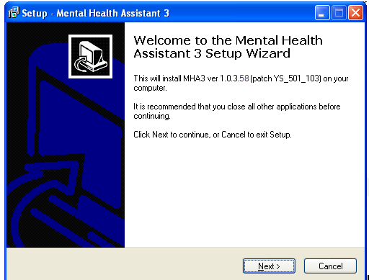

Choose Destination Location

Example: The Choose Destination Location dialog box text asks “Which directory do you want to install this program into? We strongly recommend that, while the drive may be modified, the default directory structure be used (Drive:\Program Files\Vista\YS\MHA3).

To install to the directory displayed below, click on the Next button.

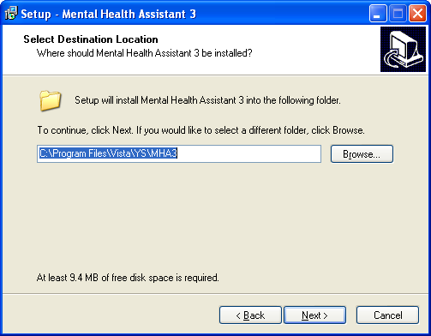

To install to a different directory, click Browse and select another directory.
Folder Does Not Exist

Example: The Folder Does Not Exist dialog box text asks “The folder: C:\Program Files\Vista\YS\MHA3 does not exist. Would you like the folder to be created?

To create the folder displayed below, click Yes.

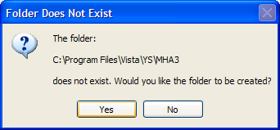

If the button No is clicked the folder is not created and you are returned to the Select Destination dialog box.

Select Start Menu Folder

Example: The Select Start Menu Folder dialog box text asks “Where should Setup place the program’s shortcuts? We strongly recommend that the program’s shortcuts be placed in the Start Menu Folder.

To install to the folder displayed below, click Next.

To install to a different folder, click Browse and select another directory.

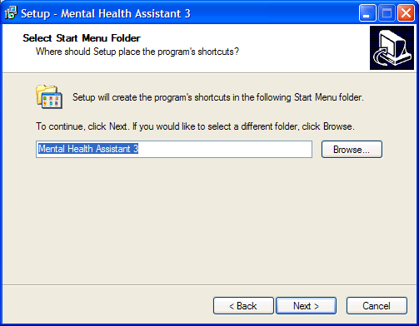

Select Additional Tasks

Example: Which additional tasks should be performed?

To install desktop icon, check the box.

To install quick launch, check the box, click Next.

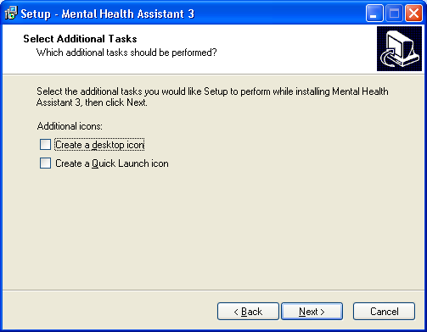
Ready to Install

Example: The Ready to Install dialog box text states “Setup is now ready to begin installing Mental Health Assistant 3 on your computer. Click Install to continue with the installation, or click Back if you want to review or change any settings. Destination location: C:\Program Files\Vista\YS\MHA3. Start Menu folder: Mental Health Assistant 3.

To continue the setup, Click Install.

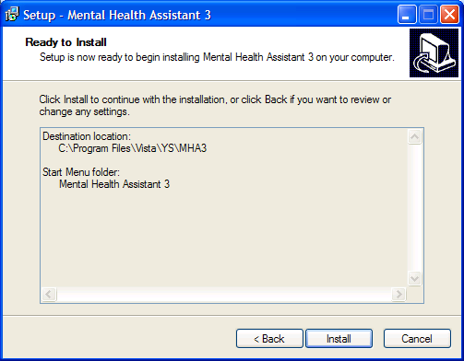

Installing Mental Health Assistant 3

Example: The Mental Health Assistant 3 Installing dialog box text states “Please wait while Setup installs Mental Health Assistant 3 on your computer.”

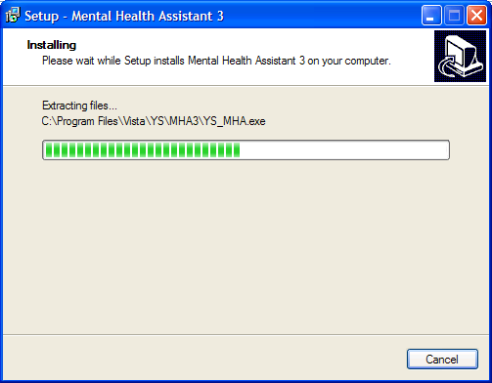

Completing the Mental Health Assistant 3 Setup Wizard

Click on the Finish command button (located within the Setup - Mental Health Assistant 3 dialog box bottom right side) to exit Setup.

Example: The Setup - Mental Health Assistant 3 dialog box text displays “Setup has finished installing Mental Health Assistant 3 on your computer. The application may be launched by selecting the installed icons.”

The first time “Instrument Administrator” is launched, it may take a couple of minutes to load all of the instruments. Subsequent launches of “Instrument Administrator” should be much quicker.

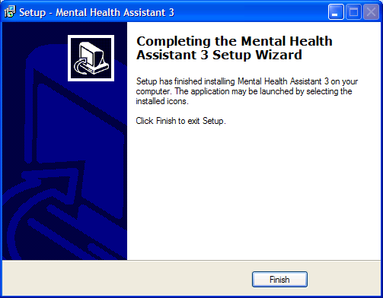

Non-M Software Distributed with Mental Health Assistant 3 (MHA3)
Please refer to Technical Manual/Security Guide.

Examples: A typical MHA3 file tree after installing MHA3:

C:\Program Files\Vista\YS\MHA3
YS_MHA.exe
YS_MHA.HLP (From Patch YS*5.01*85)
YS_MHA.JCF (From Patch YS*5.01*85)
Borlndmm.dll
Unins000.dat
unins000.exe
C:\Program Files\Vista\Common Files
YS_MHA_A.dll
YS_MHA_AUX.dll

C:\Documents and Settings\VHAXXXCliniJ.VHAXX\Application Data\MHA3 is an example path. The actual path will vary with the current user’s configuration.

C:\Documents and Settings\VHAXXXCliniJ.VHAXX\Application Data\MHA3\Answer Files
This is usually empty, unless there are off-line records that haven’t been uploaded to VistA yet. Example filename: 2~3050623-134647~AUDIT.adm.

C:\Documents and Settings\VHAXXXCliniJ.VHAXX\Application Data\MHA3\ Instrument Files
There are usually a large number of files in this folder; all of them are instrument definition files. Example filename: AUDIT~3040624.res.

Example: Files added to the MHA3 file tree after installing the optional SecureDesktop software from Patch YS*5.01*85, YS50185_SD_SETUP_1_0_2_77.exe.

c:\Program Files\Vista\YS\MHA3
YS_MHA_SD_INSTALLGINA.exe
YS_MHA_SD_UNINSTALLGINA.exe
YS_MHA_VASD.exe

C:\Windows\System32
dwlGina2.dll

Post Installation Instructions

Uninstalling MHA3

- Click on the Start Button
- Click on All Programs
- Find the Mental Health Assistant 3 icon group
- Click on the Uninstall Mental Health Assistant entry, as shown below.

Example: MHA3 menu entries on the Windows Start menu. Click on the Uninstall Mental Health Assistant entry.

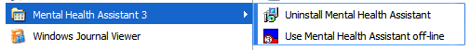

Example: Confirmation screen to remove Mental Health Assistant 3. Click on Yes.

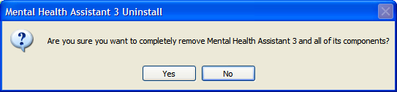

Example: Confirmation screen to that Mental Health Assistant 3 has been uninstalled. Click on the Ok button. MHA3 is now uninstalled.

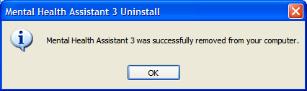

Installing SecureDesktop Functionality in MHA3

The optional Patient-Entry functions built into MHA3 are disabled by default and by design, and should only be enabled if there is a need to use MHA3 for patient-self-administered assessments. If SecureDesktop is installed, it must be installed after MHA3 is installed.

NOTE: Only users with Administrator Privileges are able to install or uninstall SecureDesktop.

SecureDesktop files are installed or uninstalled using a separate setup file than the one for installing MHA3. All the files necessary to use SecureDesktop are bundled in a single setup file. The SecureDesktop files MUST be installed to the same folder as the one containing the main MHA3 file (YS_MHA.exe)—this is why MHA3 must be installed first.

NOTE: MHA3 requires a custom version of SecureDesktop, which is distributed along with MHA3. No other distributions of SecureDesktop will work with MHA3 as of this writing.

PRIOR to installing the Secure Desktop, the Patient Entry button on MHA3’s Instrument Administrator form is disabled, and these functions are not available to the user.

Example: To start the installation process, execute the file named YS50185_SD_SETUP_1_0_2_77.exe. This is available on the Office of Information Field Offices (OIFOs) ANONYMOUS SOFTWARE_ARCHIVE directory FTP sites. Download as a binary type of file.

This action will display the following Setup – SecureDesktop for Mental Health Assistant 3 screen. Click on the Next button to continue the installation process.

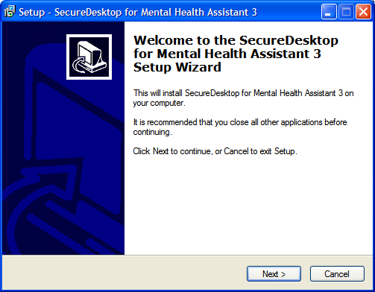

NOTE: SecureDesktop must be installed to the same folder where MHA3 was installed.

Example: Folder selection screen. Click on the Next button.

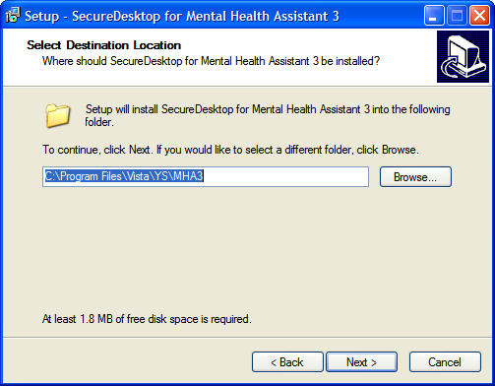

Example: Folder Exists screen. If MHA3 is already installed—as recommended, the Folder Exists confirmation dialog is shown. Click on the Yes button to install to that folder.

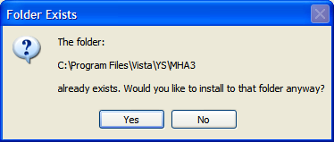
Example: Select Start Menu Folder screen. To continue creating the program’s shortcuts in the Start Menu Folder - click on the Next button.

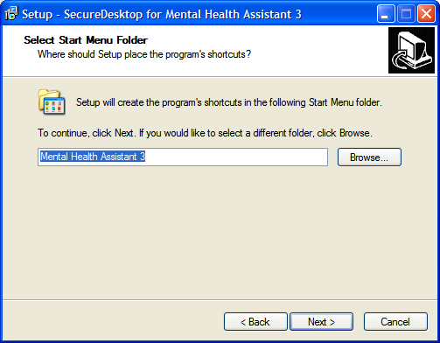
Example: Ready to Install screen. Click on the Install button to continue with installing SecureDesktop for Mental Health Assistant 3 on your computer.

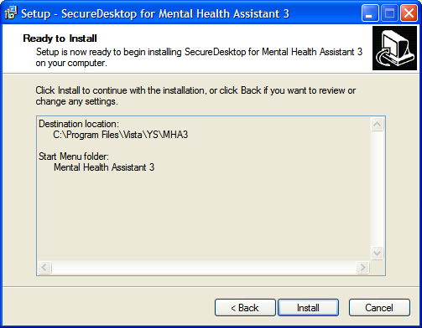
Example: Install progress screen.

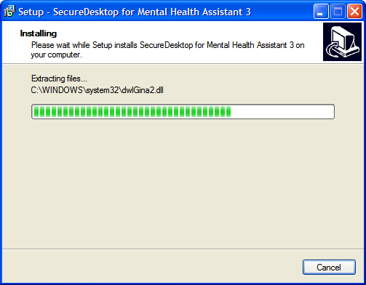

NOTE: Clicking on the Finish button will cause your computer to restart, so be sure to save any unsaved data before you click on Finish.

Example: Restart computer screen. Click Finish, to complete the installation procedure.

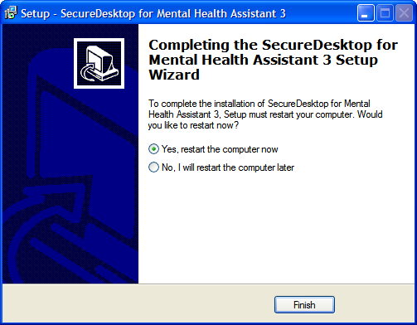

Example: Before installing SecureDesktop, the Patient Entry button on MHA3’s Instrument Administrator form is disabled, and these functions are not available to the user, as shown below.

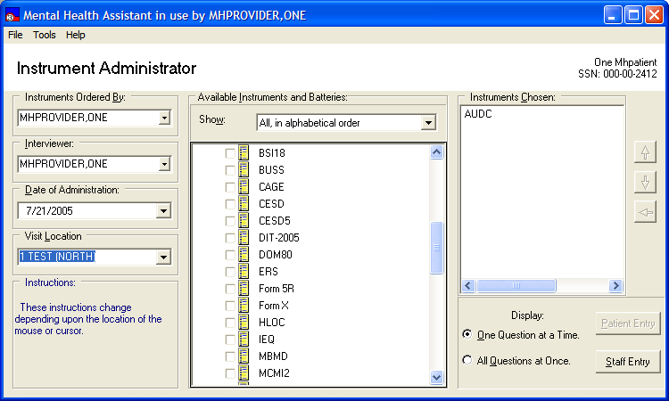

Example: After installing SecureDesktop, the Patient Entry button on MHA3’s Instrument Administrator form is enabled, and these functions become available to the user, as shown below. A test must also be selected in order to activate the Patient Entry button.

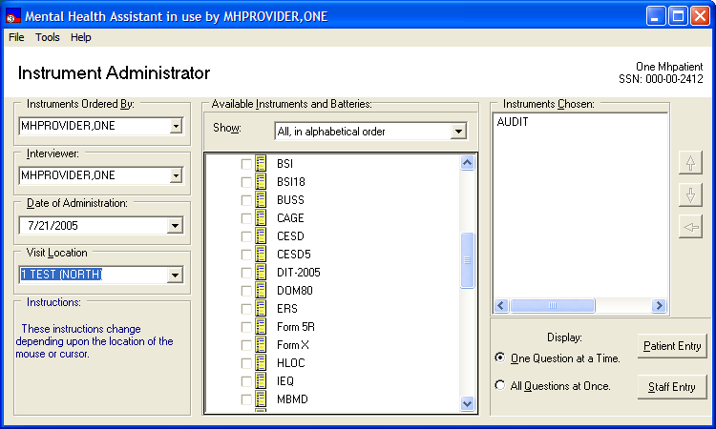

NOTE: These requirements must be met to activate SecureDesktop:

- MHA3 is properly installed on the LOCAL workstation (NOT a fileserver).
- The PC’s operating system is Windows XP
- The dwlGina2 DLL has been installed successfully. This is done automatically, when installing SecureDesktop.
- The PC was rebooted after installing SecureDesktop

Uninstalling SecureDeskstop

- Click on the Start Button
- Click on All Programs
- Find the Mental Health Assistant 3 icon group
- Click on the Uninstall SecureDesktop for MHA3 entry, as shown below.

Example: MHA3 menu entries on the Windows Start menu. Click on the Uninstall SecureDesktop for MHA3 entry.

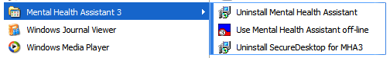

Example: Confirmation screen to remove SecureDesktop. Click on Yes.

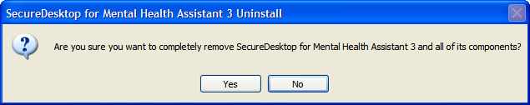

Example: Confirmation screen to restart computer. You must restart the computer after uninstalling SecureDesktop. Click on the Yes button. Be sure to save any unsaved data before you click on Yes. The Patient-Entry feature will no longer be available on MHA3.

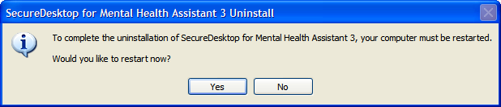

SecureDesktop & Screen Pass : How to correct Windows-Registry problems.

According to the Birch Grove Software site:
“Screen Pass is a screen locking system for Windows® that extends the capability of the standard workstation lock and gives network administrators complete control over idle workstations.
With Screen Pass, network administrators can enforce screensaver password use, screensaver timeout, and screen saver selection. Advanced features include automatic logout, automatic shutdown, customizable administrator override, and auditing of all logon/logoff and lock/unlock events.
Intended primarily for workstations connected to Novell Netware or Microsoft networks, Screen Pass can be distributed and managed remotely with or without group policy. The central management feature makes Screen Pass ideal for small, medium, and large networks - anywhere that security of idle workstations is a concern.”
Screen Pass installs its own version of a gina.dll and it may take precedence over the one used by Secure Desktop. If SecureDesktop does operate properly these changes may be necessary in the Windows Registry:

HKEY_LOCAL_MACHINE\SOFTWARE\Microsoft\Windows NT\CurrentVersion\Winlogon\GinaDLL=dwlgina2.dll

HKEY_LOCAL_MACHINE\SOFTWARE\Microsoft\Windows NT\CurrentVersion\Winlogon\GinaDLL_ScreenPass=msgina2.dll

See Remedy Ticket # HD0000000278953.

SecureDesktop : How to correct dwlGina2.dll problems.

A dwlGina2.dll error problem may occur when a non-administrator uninstalls MHA3 without an administrator first de-activating SecureDesktop.

Here is how to fix it:
1. Turn off defective PC, if on.
2. Start the PC and Windows in SAFE mode.
3. Logon as Administrator.
4. Find the media containing the YS_MHA_SD_UNINSTALLGINA.exe file. These files are typically found at C:\Program Files\Vista\YS\MHA3. Run YS_MHA_SD_UNINSTALLGINA.exe. Click Yes, to uninstall it.
5. Reboot in normal mode.

If this doesn’t work, then modify step five by first finding and running YS_MHA_SD_INSTALLGINA.exe. Click Yes, to install it. Then follow the remainder of step five.

Setting up VistA MHA3 on CPRS GUI Tools Menu

WARNING: THIS STEP IS MANDATORY, TO COMPLETE THE VistA MHA3 INSTALLATION PROCESS.

This procedure configures VistA so that “Mental Health Assistant” appears as a choice on a user’s Tools menu on the CPRS desktop software. Unlike previous versions of MHA, where this was optional, Version 3 of VistA MHA MUST be started from the CPRS Tools Menu. Selecting this choice from the CPRS Tools menu will offer the user full MHA3 functionality, based on a user’s particular access permissions in VistA.

The basic steps for setting up VistA MHA3 on the Tools menu are no different from doing it for other applications. The main difference lies in how the Name=Command entry is formatted. The following text capture is taken from the CPRS Setup documentation, to serve as an example of how to perform this step for MHA3:

Example: Setting up VistA MHA3 on the CPRS Tools menu, GUI Parameters [ORW PARAM GUI]

Select GUI Parameters Option: tm GUI<ENTER> Tool Menu Items
CPRS GUI Tools Menu may be set for the following:<ENTER>
1 User USR [choose from NEW PERSON]
2 Location LOC [choose from HOSPITAL LOCATION]
3 Division DIV [REGION 5]
4 System SYS [OEX.ISC-SLC.VA.GOV]
Enter selection: 1<ENTER> User NEW PERSON
Select NEW PERSON NAME: MHPROVIDER,ONE<ENTER> CPF
------------- Setting CPRS GUI Tools Menu for User: MHPROVIDER,ONE----------
Sequence: ? <ENTER>
Enter the sequence in which this menu item should appear.
Select Sequence: 2
Are you adding 2 as a new Sequence? Yes//<ENTER> YES
Sequence: 2// <Enter>
Name=Command: Mental Health Assistant=C:\Progra~1\Vista\YS\MHA3\YS_MHA.exe s=%SRV p=%PORT c=%DFN u=%DUZ m=%MREF
From the previous example, adjust according to your own system’s settings, such as New Person Name and other parameters—consult the CPRS Setup Guide for the meaning of these parameters. The pertinent portion of the example is the “Name=Command:” field. This field should be entered exactly as shown, in a single line—no line-breaks allowed, including all the % parameters that follow the filename and path to the MHA3 executable file.

The path shown represents a typical path used during a default installation. If your path is different, adjust accordingly. ALL five parameters must be included as shown above, in the precise order in which they are found in the example. Here is what the Name=Command line should look like:

Example: Mental Health Assistant=C:\Progra~1\Vista\YS\MHA3\YS_MHA.exe s=%SRV p=%PORT c=%DFN u=%DUZ m=%MREF

Sequence number 2 is shown in the example, but, if you have other entries in the Tools Menu, then the next free sequence number will do just fine. (Sometimes when cutting and pasting, unseen control characters can be included in the text and will cause the command line to malfunction.)

After this step is completed, a new choice will appear in the user’s CPRS Tools Menu labeled “Mental Health Assistant”. Clicking on this menu entry will start MHA3 with a selected patient synchronized to the one currently selected in CPRS.

Refer to the Computerized Patient Record System (CPRS) Setup Guide for more information about this procedure.

Setting up VistA MHA3 on CPRS GUI Tools Menu for SecureDesktop

If your site uses an APPLICATION SERVER for access MHA3, you will need to create a 2nd instance under CPRS tools. SecureDesktop MUST access MHA3 from the LOCAL MACHINE that SecureDesktop is loaded. You cannot use MHA3 from an application server for SecureDesktop

Example: Setting up VistA MHA3 on the CPRS Tools menu for SecureDesktop, GUI Parameters [ORW PARAM GUI]

Select GUI Parameters Option: tm GUI<ENTER> Tool Menu Items
CPRS GUI Tools Menu may be set for the following:<ENTER>
1 User USR [choose from NEW PERSON]
2 Location LOC [choose from HOSPITAL LOCATION]
3 Division DIV [REGION 5]
4 System SYS [OEX.ISC-SLC.VA.GOV]
Enter selection: 1<ENTER> User NEW PERSON
Select NEW PERSON NAME: MHPROVIDER,ONE<ENTER> CPF
------------- Setting CPRS GUI Tools Menu for User: MHPROVIDER,ONE----------
Sequence: ? <ENTER>
Enter the sequence in which this menu item should appear.
Select Sequence: 2
Are you adding 2 as a new Sequence? Yes//<ENTER> YES
Sequence: 2// <Enter>
Name=Command: MHA3_Patient Entry=C:\Progra~1\Vista\YS\MHA3\YS_MHA.exe s=%SRV p=%PORT c=%DFN u=%DUZ m=%MREF

From the previous example, adjust according to your own system’s settings, such as New Person Name and other parameters—consult the CPRS Setup Guide for the meaning of these parameters. The pertinent portion of the example is the “Name=Command:” field. This field should be entered exactly as shown, in a single line—no line-breaks allowed, including all the % parameters that follow the filename and path to the MHA3 executable file.

ALL five parameters must be included as shown above, in the precise order in which they are found in the example. Here is what the Name=Command line should look like:
Example: MHA3_Patient Entry=C:\Progra~1\Vista\YS\MHA3\YS_MHA.exe s=%SRV p=%PORT c=%DFN u=%DUZ m=%MREF
Sequence number 2 is shown in the example, but, if you have other entries in the Tools Menu, then the next free sequence number will do just fine. (Sometimes when cutting and pasting, unseen control characters can be included in the text and will cause the command line to malfunction.)

After this step is completed, a new choice will appear in the user’s CPRS Tools Menu labeled “MHA3_Patient Entry”. Clicking on this menu entry will start MHA3 with a selected patient synchronized to the one currently selected in CPRS and if SecureDesktop is installed on that machine, the Patient Entry Button will be enabled.

Setting up VistA so that individual MHA3 assessments are also listed on the CPRS GUI Tools Menu

NOTE: THIS STEP IS OPTIONAL

This procedure configures VistA so that you can add a variable number of individual, specific assessment-types choices, to the Tools menu in the CPRS GUI. This is in addition, or instead of, the Mental Health Assistant choice described above. This step is optional and will have no effect on the procedure described above.

The steps for setting up individual assessment types are identical to setting up MHA3, with one significant difference: The Name=Command line has one added parameter at the end of the parameter list. This parameter indicates the “code” name of the instrument to be added to the Tools menu. In this example, CAGE is added to the Tools menu. Here is what the Name=Command line should look like to add CAGE:

Example: Mental Health Assistant=C:\Progra~1\Vista\YS\MHA3\YS_MHA.exe s=%SRV p=%PORT c=%DFN u=%DUZ m=%MREF CAGE

As above, this entire Name=Command line should be on one line—no carriage returns, and the next open sequence number on the menu will work fine.

Example: Two new entries on the CPRS Tools menu; Mental Health Assistant and CAGE (individual assessment type).

